**Program Scenario**

**GenAI Consulting Team**

**Who You Are**

**YOU**

**PITIPARK**

***Data scientist***

A role focused on applying AI and data analysis skills to develop AI-powered tools, such as a financial chatbot, while learning to translate complex data into strategic business insights.

**Your Team**

**MANAGER**

**Aisha**

***Senior data scientist***

Aisha is a renowned and skilled senior data scientist at BCG, recognized for her leadership of the GenAI Consulting team and her expertise in integrating AI with financial analytics for strategic consulting solutions.

# **Project brief**

**Background context**

The GenAI Consulting team at BCG has been approached by a leading global financial institution, Global Finance Corp. (GFC), to address a pressing challenge in their operations. GFC, amid a rapidly evolving financial landscape, is seeking to enhance its capabilities in analyzing corporate financial performance. They have identified a need for a sophisticated, AI-driven solution to stay ahead in the market and provide their clients with deeper, more accessible insights into corporate financial health.

GFC's traditional methods of financial analysis, though reliable, have become time-consuming and less efficient in the face of increasing data volumes and the fast pace of financial markets. They are looking to BCG, known for its cutting-edge AI solutions, to develop a tool that can quickly analyze and interpret large sets of financial data, specifically from 10-K and 1 0-Q reports.

**The project**

Your role as a junior data scientist in the GenAI Consulting team is pivotal in developing an AI-powered chatbot that can analyze and provide insights on corporate financial performance from 10-K and 10-Q financial documents. This chatbot is intended to revolutionize the way GFC and its clients interact with financial data, making complex information easily accessible and understandable through conversational AI.

**Key terms**

* **10-K and 10-Q reports**: Annual and quarterly financial reports filed by publicly traded companies containing detailed information about financial performance.
* **GenAI**: A branch of AI focusing on generating new content, including text and data analysis, which is crucial for the chatbot's ability to interpret and communicate financial data.
* **Natural language processing (NLP)**: An AI technology that the chatbot will use to understand and respond to user queries in natural language.

**Specific project requirements and outcomes**

* **Efficiency**: The solution must significantly reduce the time taken to analyze financial documents compared to traditional methods.
* **Accuracy**: The chatbot should provide precise and reliable financial insights backed by thorough data analysis.
* **User-friendly interface**: The chatbot should be intuitive and easy to use for GFC’s diverse client base, regardless of their financial expertise.
* **Scalability**: The solution should be scalable – capable of handling an increasing number of documents and user queries.

The pressure is high, as GFC is looking to implement this solution in the upcoming financial quarter. The GenAI Consulting team is feeling a mix of excitement and urgency, understanding the impact this project could have on their reputation and future opportunities. As a junior data scientist, you are expected to bring fresh perspectives and innovative solutions, working under the guidance of your manager, Aisha, to meet these high expectations. The team is geared up for a challenging yet rewarding journey, aiming to deliver a groundbreaking tool in the field of financial analytics.

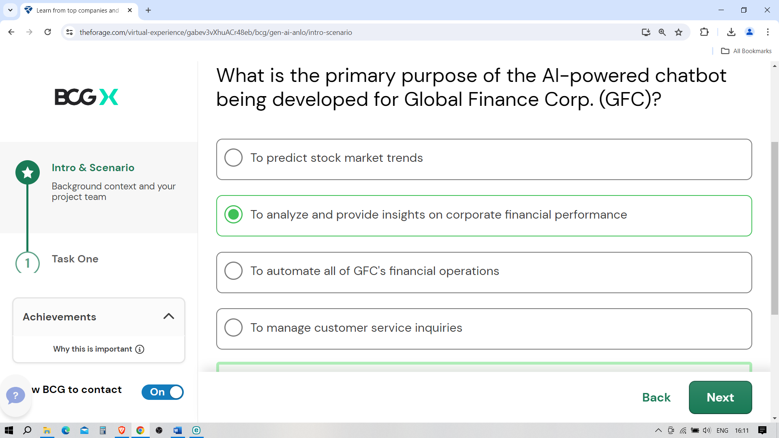

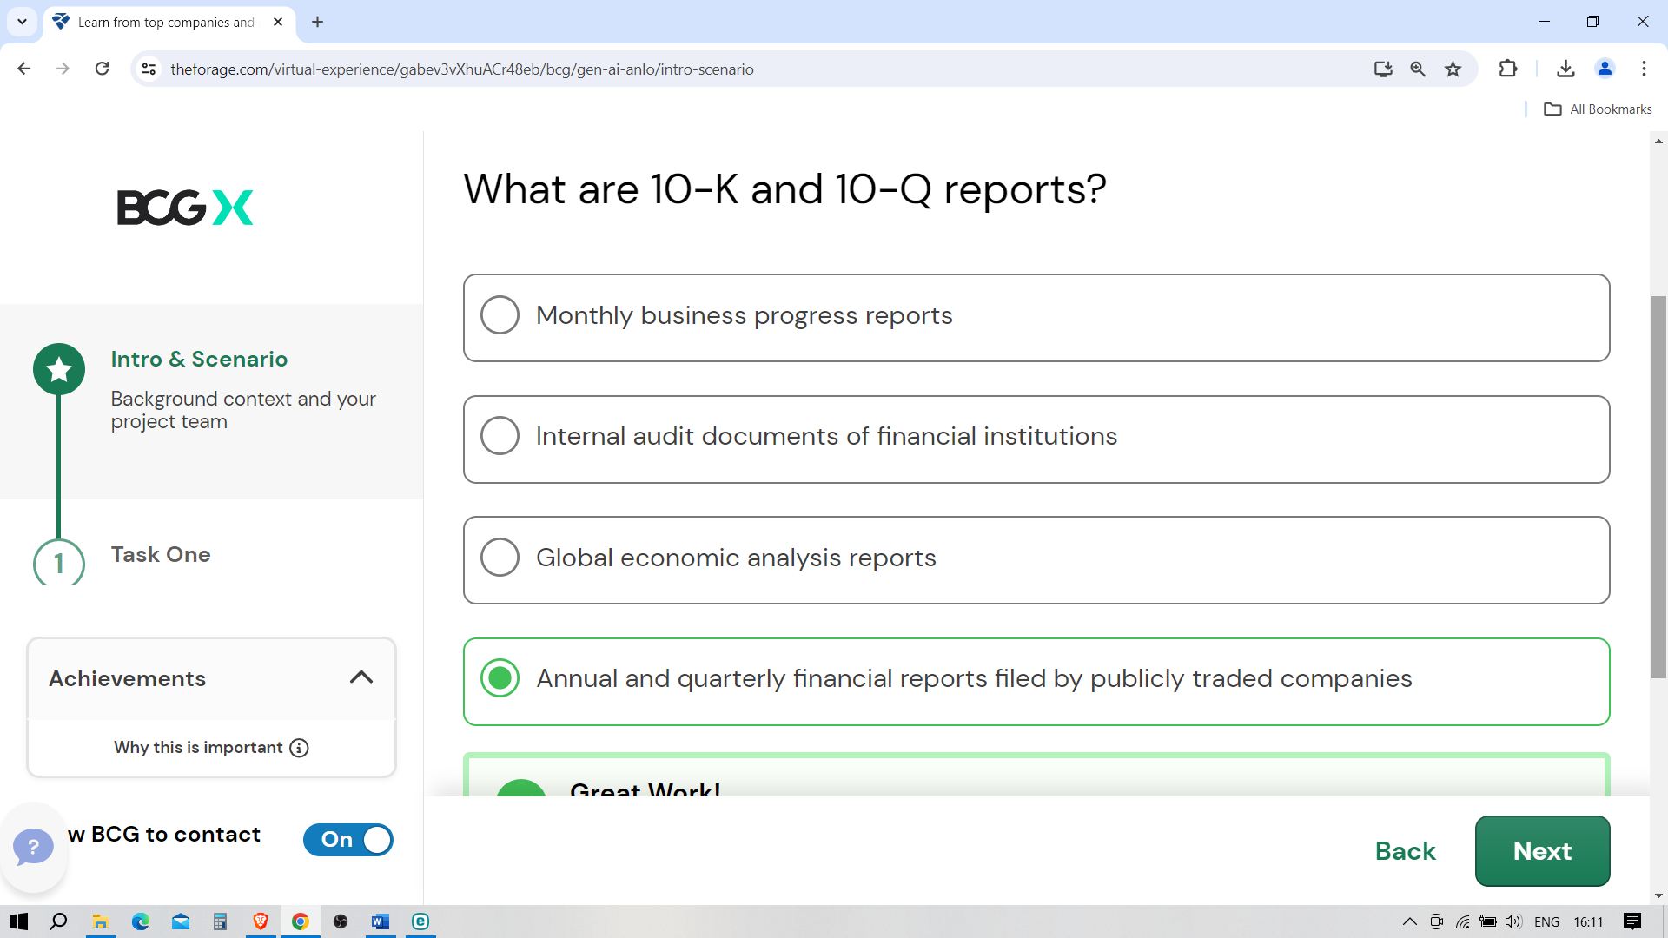

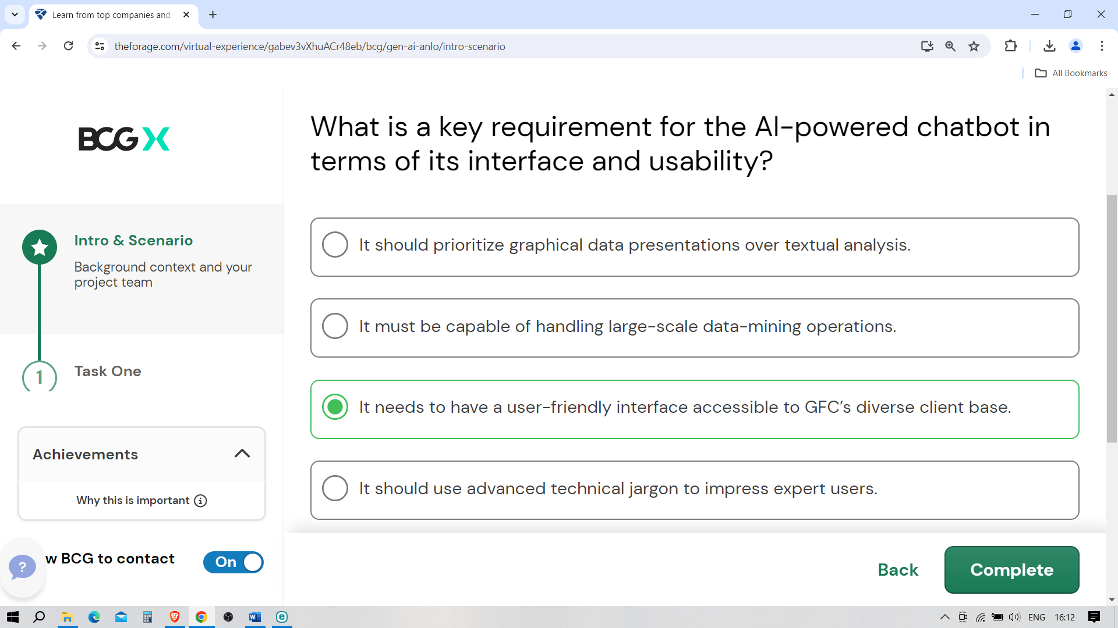

**Task 1: Data extraction and initial analysis**

Task overview

Let’s get started on your first task!

**What you'll learn**

* Techniques for extracting key financial data from 10-K documents.
* Understanding financial statement components and performance metrics.
* Preparing and processing data for AI-driven applications.

**What you'll do**

* Extract financial data from provided 10-K documents.
* Conduct a basic analysis to identify significant financial trends and indicators.
* Format and clean the data for further processing in an AI model.

Welcome to the GenAI Job Simulation

We’re so excited to have you here with us!

**Your Role**

* You are a junior data scientist at Boston Consulting Group (BCG), specifically part of the GenAI consulting team.
* Your team consists of diverse talents, each contributing unique skills and perspectives to the projects. You are the newest addition to this dynamic team.
* You have been given the responsibility of developing an AI-powered chatbot that analyzes financial documents. This is a cutting-edge project at the intersection of finance and generative AI (GenAI), a growing area of interest and investment at BCG.
* As an ambitious junior data scientist eager to make your mark, you see this as a golden opportunity to apply your technical expertise in AI and data analysis while also learning about the financial domain.

**Your Goal**

* Your primary objective is to extract and analyze key financial data from the client's 10-K and 10-Q documents. This involves understanding financial statements, identifying significant trends, and preparing data for AI-driven applications.
* Following the data analysis, you will develop an AI-powered financial chatbot. This chatbot must be capable of analyzing financial data and providing insights that effectively communicate complex financial information in an interactive and user-friendly manner.
* Throughout the project, your focus will not only be on the technical execution but also on how these AI-driven insights can be leveraged in a consulting context to provide strategic recommendations and solutions to clients.

# **Let's get started**

Welcome to the first task of your journey as a junior data scientist with BCG's GenAI Consulting team. In this initial phase, you are not just undertaking a task; you're laying the cornerstone for a sophisticated AI-driven financial analysis project. Let's explore why this task is not only crucial but also a transformative learning opportunity.

**Understanding the project requirements**

* **Contextualizing AI in finance**: This task immerses you in the real-world application of AI in finance. By extracting and analyzing data from 10-K documents, you'll understand how AI can transform raw financial data into insightful analytics.
* **Identifying key financial indicators**: The ability to discern which data points are critical for financial assessment is fundamental. This task will enhance your acumen in recognizing significant financial metrics crucial for AI analysis.

**Determining important factors for AI integration**

* **Data quality assessment**: The success of AI heavily depends on the quality of data it is fed. Through this task, you'll learn to identify and extract high-quality, relevant financial data, setting a strong foundation for accurate AI modeling.
* **Understanding data structure**: AI models require data in specific formats. This task will help you comprehend the structuring of financial data, which is a pivotal step in preparing it for AI integration.

This task will allow you to develop a deep understanding of financial data analysis and its significance in AI applications. It's about setting the tone and foundation for the rest of your project. As you begin this task, remember that the insights and skills you gain here are key to your growth as a data scientist and the success of the project with your client, GFC. Let's dive in!

Getting briefed

**Subject:** Initiation: Financial Data Analysis for GFC AI Chatbot Project  
**From:** [aisha@bcg.com](mailto:aisha@bcg.com)  
**To:** forager@bcg.com

Dear Forager,

We have just kicked off a pivotal project with Global Finance Corp. (GFC), focusing on developing an AI-powered chatbot to revolutionize their financial data analysis. Your contribution, starting with extracting and analyzing data from financial documents, is essential to the project’s success.

**Project context:**

* Our goal is to extract meaningful insights from 10-K financial reports.
* These insights will feed into the AI chatbot, enabling it to provide in-depth financial performance analysis.

**Your role and responsibilities**

**Data extraction**:

* Research and review 10-K documents.
* Focus on key financial figures and ratios.

**Basic analysis**:

* Identify significant financial trends and indicators.
* Assess the financial health and performance of the companies.

**Data preparation**:

* Format and clean the data for AI model integration.

**Deliverable**:

* A comprehensive data analysis report, which should include:
  + your findings
  + a summary providing insights into the financial health of the analyzed companies.

This initial task will set the foundation for our AI model and is instrumental in moving the project forward. Your attention to detail and analytical skills will be key in this phase.

Feel free to reach out for any assistance or clarification needed during this process. I am eager to see the insights you will uncover and how they will shape our project’s trajectory.

Best regards,

Aisha  
Senior Data Scientist   
GenAI Consulting Team, BCG

Techniques for extracting key financial data from 10-Ks

10-K reports are comprehensive annual reports filed with the SEC by publicly traded companies. They provide a detailed account of a company's financial performance, including audited financial statements, management's discussion and analysis (MD&A), and disclosures about market risk, controls, and legal proceedings.

**Key sections to focus on for financial data extraction:**

* **Income statement**: This section provides information about the company's revenue, costs, and expenses over a specific period of time.
  + **Key data points**: Total revenue, cost of goods sold (COGS), operating expenses, and net income.
  + **Extraction technique**: Look for the income statement summary, typically in the early pages of the reports. Pay attention to year-over-year changes.
* **Balance sheet**: This section outlines the company’s assets, liabilities, and the shareholders’ equity at a specific point in time.
  + **Key data points**: Current assets, long-term assets, current liabilities, long-term liabilities, and total shareholders’ equity.
  + **Extraction technique**: Focus on the balance sheet summary. Compare assets against liabilities to understand the company’s financial health and note any large changes in assets or liabilities.
* **Cash flow statement**: This shows how changes to the balance sheet and income impact cash and cash equivalents.
  + **Key data points**: Cash from operating activities, investing activities, and financing activities.
  + **Extraction technique**: Analyze the cash flow statement to understand how the company generates and spends its cash. This can provide insights into a company's liquidity.

**Effective techniques for data extraction:**

* **Manual extraction**: Start by manually reviewing the documents to understand their layout and where key information is typically found.
* **Highlight and annotate**: Use digital tools to highlight and annotate key figures and notes for easy reference.
* **Excel and spreadsheet tools**: For quantitative data, using Excel or similar spreadsheet tools can be effective. You can input key figures into a spreadsheet for analysis and comparison.
* **Automated extraction tools**: For more advanced users, tools such as Python (in particular, libraries such as Beautiful Soup or Pandas) can automate the extraction of data from these documents, especially if they are available in digital formats.

By understanding the structure of 10-K reports and mastering these extraction techniques, you can efficiently gather the necessary financial data for analysis and further application in AI-driven tools.

How to Read a 10-K/10-Q

**Jan. 25, 2021**

If you want to follow or invest in a U.S. public company, you can find a wealth of information in the company’s annual reports on [Form 10-K](https://www.investor.gov/introduction-investing/investing-basics/glossary/form-10-k) and quarterly reports on [Form 10-Q](https://www.investor.gov/introduction-investing/investing-basics/glossary/form-10-q). Among other things, the 10-K and 10-Q offer a detailed picture of a company’s business, the risks it faces, and the operating and financial results for the fiscal year or quarter, as applicable. Company management also discusses its perspective on the business results and what is driving them.

Most U.S. public companies are required to file a 10-K each year with the U.S. Securities and Exchange Commission (SEC). (Non-U.S. public companies usually file their annual reports with the SEC on different forms.) SEC rules require that 10-Ks follow a set order of topics.  The Form 10-Q is required to be filed after the first, second and third fiscal quarter.

SEC rules also require companies to send an [annual report](http://www.sec.gov/answers/annrep.htm) to their shareholders when they are holding annual meetings to elect members of their boards of directors. There is a lot of overlap in the requirements for the 10-K and the annual report to shareholders, but there are also important differences. The 10-K typically includes more detailed information than the annual report to shareholders. The annual report to shareholders, unlike the 10-K, sometimes appears as a colorful, glossy publication. A number of companies, however, simply take their 10-K and send it as their annual report to shareholders. In those cases, the 10-K filed with the SEC and the annual report to shareholders are the same document.

**The Roles of Companies and the SEC**

The company prepares the 10-K and 10-Q and files it with the SEC. Laws and regulations prohibit companies from making materially false or misleading statements. Likewise, companies are prohibited from omitting material information that is needed to make the disclosure not misleading. In addition, a company’s CFO and CEO must certify to the accuracy of the 10-K and 10-Q.

The SEC does not vouch for the accuracy of a 10-K or 10-Q. The SEC sets the disclosure requirements – the topics that all companies must cover in their 10-Ks or 10-Qs, and how the information should be presented.

The SEC staff reviews 10-Ks and 10-Qs to monitor and enhance companies’ compliance with the requirements. Both the SEC and the staff also provide interpretive advice about the disclosure requirements. The SEC staff reviews 10-Ks and may provide comments to a company where disclosures appear to be inconsistent with the disclosure requirements or deficient in explanation or clarity. The Sarbanes Oxley Act requires the SEC to review every public company’s financial statements at least once every three years. The SEC staff may review the 10-Ks and 10-Qs of certain companies more frequently.

All 10-Ks and 10-Qs filed with the SEC are available to the public on the SEC’s EDGAR website. Most companies also post their 10-Ks and 10-Qs on their own websites.

**Items in the Annual Report on Form 10-K**

**Part I**

**Item 1**“Business” requires a description of the company’s business, including its main products and services, what subsidiaries it owns, and what markets it operates in. This section may also include information about recent events, competition the company faces, regulations that apply to it, labor issues, special operating costs, or seasonal factors. This is a good place to start to understand how the company operates.

**Item 1A**“Risk Factors” includes information about the most significant risks that apply to the company or to its securities. Companies generally list the risk factors in order of their importance. In practice, this section focuses on the risks themselves, not how the company addresses those risks. Some risks may be true for the entire economy, some may apply only to the company’s industry sector or geographic region, and some may be unique to the company.

**Item 1B**“Unresolved Staff Comments” requires the company to explain certain comments it has received from the SEC staff on previously filed reports that have not been resolved after an extended period of time. Check here to see whether the SEC has raised any questions about the company’s statements that have not been resolved.

**Item 2**“ Properties” includes information about the company’s significant physical properties, such as principal plants, mines and other materially important physical properties.

**Item 3**“Legal Proceedings” requires the company to include information about significant pending lawsuits or other legal proceedings, other than ordinary litigation.

**Item 4**”Mine Safety Disclosures” requires disclosure, if applicable, of. Information concerning mine safety violations, among other things.

**Part II**

**Item 5** “Market for Registrant’s Common Equity, Related Stockholder Matters and Issuer Purchases of Equity Securities” requires information about the company’s equity securities, including market information, the number of holders of the shares, dividends, stock repurchases by the company, and similar information.

**Item 6**This item has no required information, but is reserved by the SEC for future rulemaking.  Prior to February 2021, however, this item was titled “Selected Financial Data” and  required summarized financial data about the company for the last five years.

**Item 7** “Management’s Discussion and Analysis of Financial Condition and Results of Operations” gives the company’s perspective on the business results of the past financial year. This section, known as the MD&A for short, allows company management to tell its story in its own words. The MD&A presents:

* The company’s operations and financial results, including information about the company’s liquidity and capital resources and any known trends or uncertainties that could materially affect the company’s results. This section may also discuss management’s views of key business risks and what it is doing to address them.
* Material changes in the company’s results compared to a prior period.
* Critical accounting judgments, such as estimates and assumptions. These accounting judgments – and any changes from previous years – can have a significant impact on the numbers in the financial statements, such as assets, costs, and net income.

|  |
| --- |
| Discussion of Risk in the MD&A  Here are examples of how an MD&A may discuss risks that the company faces.   * A consumer company might discuss ways in which it seeks to meet changing tastes. * A manufacturing company that relies on natural resources may discuss how it assesses commodity risks and conducts resource management programs. * A financial institution may discuss ways that management monitors liquidity and assures adequate capital under various scenarios, such as a rise in interest rates or a ratings downgrade. * A global company may discuss how it handles exchange rate risks. * Companies may discuss how they handle competition, build their brands, or manage in an economic downturn. * Companies also may discuss how they ensure compliance with laws and regulations, or how they are addressing the impact of new or anticipated laws and regulations. |

**Item 7A** “Quantitative and Qualitative Disclosures about Market Risk” requires information about the company’s exposure to market risk, such as interest rate risk, foreign currency exchange risk, commodity price risk or equity price risk. The company may discuss how it manages its market risk exposures.

**Item 8**“Financial Statements and Supplementary Data” requires the company’s audited financial statements. This includes the company’s income statement (which is sometimes called the statement of earnings or the statement of operations), balance sheets, statement of cash flows and statement of stockholders’ equity. The financial statements are accompanied by notes that explain the information presented in the financial statements.

U.S. companies are required to present their financial statements according to a set of accounting standards, conventions and rules known as Generally Accepted Accounting Principles, or GAAP. An independent accountant audits the company’s financial statements. For large companies, the independent accountant also reports on a company’s internal controls over financial reporting.

The auditor’s report is a key part of the 10-K. Most audit reports express an “unqualified opinion” that the financial statements fairly present the company’s financial position in conformity with GAAP. If, however, an auditor expresses a “qualified opinion” or a “disclaimer of opinion,” investors should look carefully at what kept the auditor from expressing an unqualified opinion. Likewise, investors should carefully evaluate material weaknesses disclosed on internal controls over financial reporting.

In addition, a company’s CEO and CFO must certify that the 10-K is both accurate and complete. These are called Sections 302 and 906 certifications, and you can usually find them in Exhibits 31 and 32.

You may also find “non-GAAP financial measures” in the 10-K. That means that the numbers do NOT conform to GAAP. While companies are permitted to present non-GAAP measures, they must also show how they differ from the most comparable corresponding GAAP financial measure. As an investor, it is up to you to decide how much weight to give to non-GAAP measures.

**Item 9** “Changes in and Disagreements with Accountants on Accounting and Financial Disclosure” requires a company, if there has been a change in its accountants, to discuss any disagreements it had with those accountants. Many investors view this disclosure as a red flag.

**Item 9A**“Controls and Procedures” includes information about the company’s disclosure controls and procedures and its internal control over financial reporting.

**Item 9B** “Other Information” includes any information that was required to be reported on a [Form 8-K](https://www.investor.gov/introduction-investing/investing-basics/glossary/form-8-k) during the fourth quarter of the year covered by the 10-K, but was not yet reported.

**Part III**

These items cover the following topics:

**Item 10**“Directors, Executive Officers and Corporate Governance” requires information about the background and experience of the company’s directors and executive officers, the company’s code of ethics, and certain qualifications for directors and committees of the board of directors.

**Item 11**“Executive Compensation” includes detailed disclosure about the company’s compensation policies and programs and how much compensation was paid to the top executive officers of the company in the past year.

**Item 12** “Security Ownership of Certain Beneficial Owners and Management and Related Stockholder Matters” requires information about the shares owned by the company’s directors, officers and certain large shareholders, and about shares covered by equity compensation plans.

**Item 13**“Certain Relationships and Related Transactions, and Director Independence” includes information about relationships and transactions between the company and its directors, officers and their family members. It also includes information about whether each director of the company is independent.

**Item 14**“Principal Accountant Fees and Services” requires companies to disclose the fees they paid to their accounting firm for various types of services during the year. Although these disclosures are required by the 10-K, most companies meet this requirement by providing the information in a separate document called the proxy statement, which companies provide to their shareholders in connection with annual meetings. If the information is provided through the proxy statement, the 10-K would include a statement from the company that it is incorporating the information from the proxy statement by reference – in effect directing readers to go to the proxy statement document to find this information. Keep in mind that the proxy statement is typically filed a month or two after the 10-K.

**Part IV**

**Item 15**“Exhibits, Financial Statement Schedules” requires a list of the financial statements and exhibits included as part of the Form 10-K. Many exhibits are required, including documents such as the company’s bylaws, copies of its material contracts, and a list of the company’s subsidiaries.

**Items in the Quarterly Report on Form 10-Q**

The Form 10-Q provides similar but more abbreviated disclosure than the Form 10-K and as it relates to the applicable fiscal quarter.  There are fewer item disclosures than in the Form 10-K.

The Form 10-Q includes items relating to “Financial Statements,” “Management’s Discussion and Analysis of Financial Condition and Results of Operations,” “Quantitative and Qualitative Disclosures About Market Risk,” “Controls and Procedures,” “Legal Proceedings” and “Risk Factors.”  See the above discussion for a summary of the information disclosed in these items.

**Additional Resources**

Visit “[Using EDGAR to Research Investments](https://www.investor.gov/introduction-investing/getting-started/researching-investments/using-edgar-research-investments)” to learn how to use our EDGAR system including to find a company’s Form 10-K.

For additional educational information for investors, see the SEC Office of Investor Education and Advocacy’s website for investors, [Investor.gov](https://www.investor.gov/).

The Office of Investor Education and Advocacy has provided this information as a service to investors.  It is neither a legal interpretation nor a statement of SEC policy.  If you have questions concerning the meaning or application of a particular law or rule, please consult with an attorney who specializes in securities law.

Preparing and preprocessing data for AI-driven applications

**Data preparation steps:**

* **Data cleaning**: Involves correcting or removing incorrect, corrupted, or duplicate data.
  + Techniques include filling in missing values, smoothing noisy data, and resolving inconsistencies.
* **Data transformation**: This step is about normalizing and standardizing data to ensure it's in a usable format for AI models.
  + Includes converting all financial figures to a consistent format (e.g., all figures in thousands or millions) and adjusting for inflation or currency changes where necessary.

**Preprocessing for AI models:**

* **Feature engineering**: The process of using domain knowledge to create features that make machine learning algorithms work. In financial data, this might involve creating ratios or deriving financial health indicators from raw data.
* **Data encoding and formatting**: Many AI models require data in a specific format. This may involve encoding categorical data (like fiscal quarters) into numerical values or restructuring data sets for time-series analysis.
* **Dealing with time-series data**: Financial data often involves time-series analysis. Special care should be taken to handle trends and seasonality and potentially integrate lag features that capture past values.

**Key takeaways:**

* Preparing and preprocessing data is crucial for the successful application of AI in finance. It ensures that the data fed into AI models is clean, consistent, and structured in a way that maximizes the model's ability to learn and make accurate predictions or provide valuable insights.
* This stage is not just about technical execution but also understanding the financial context and relevance of the data being processed.

By mastering these skills, you can effectively prepare and preprocess financial data, making it ready for AI-driven applications.

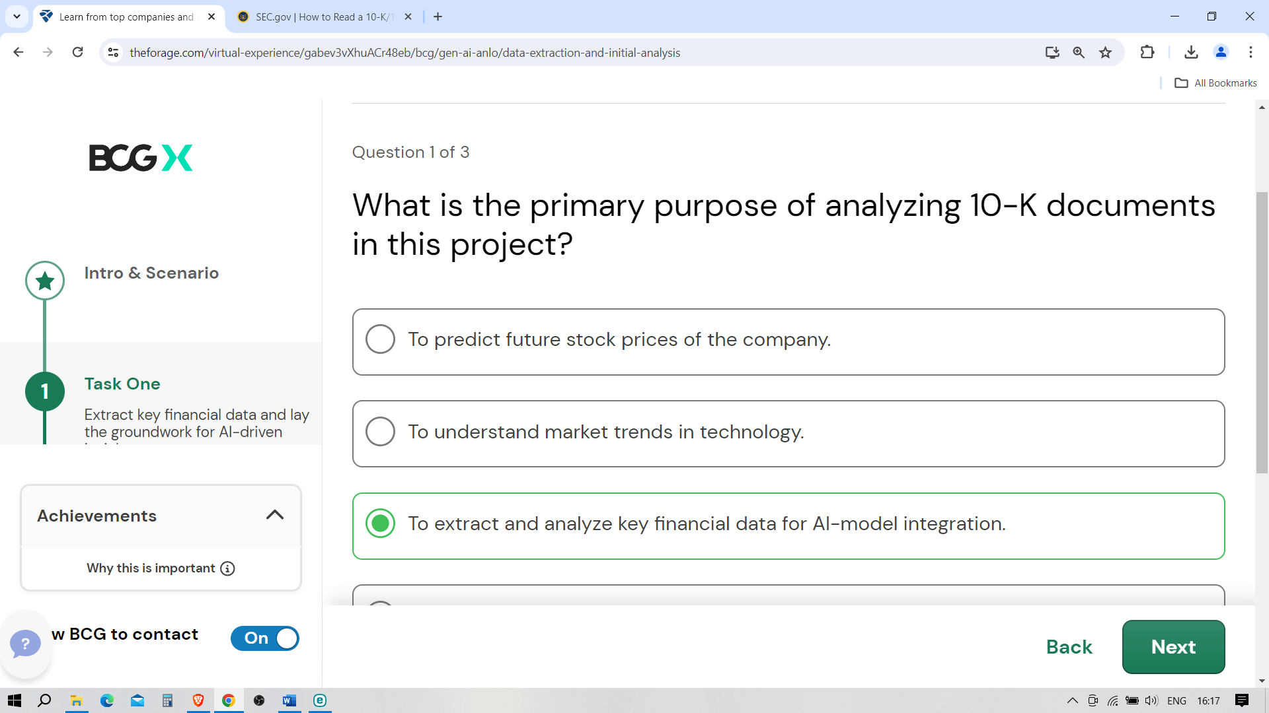

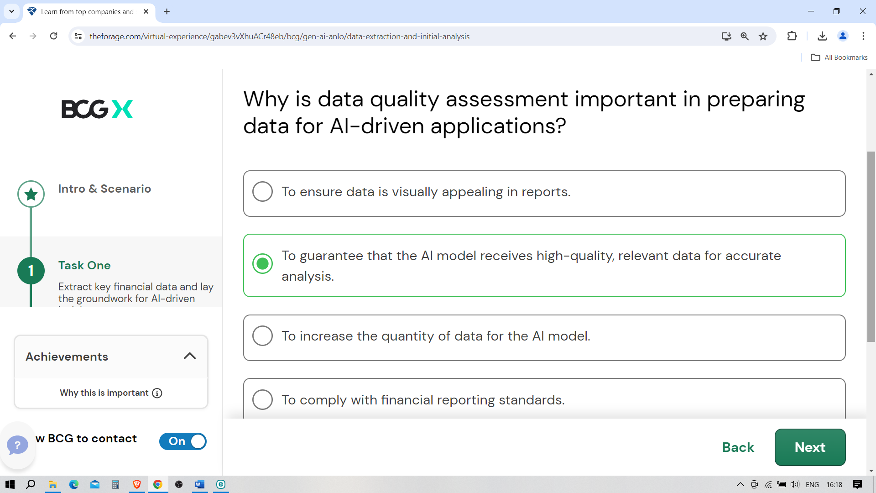

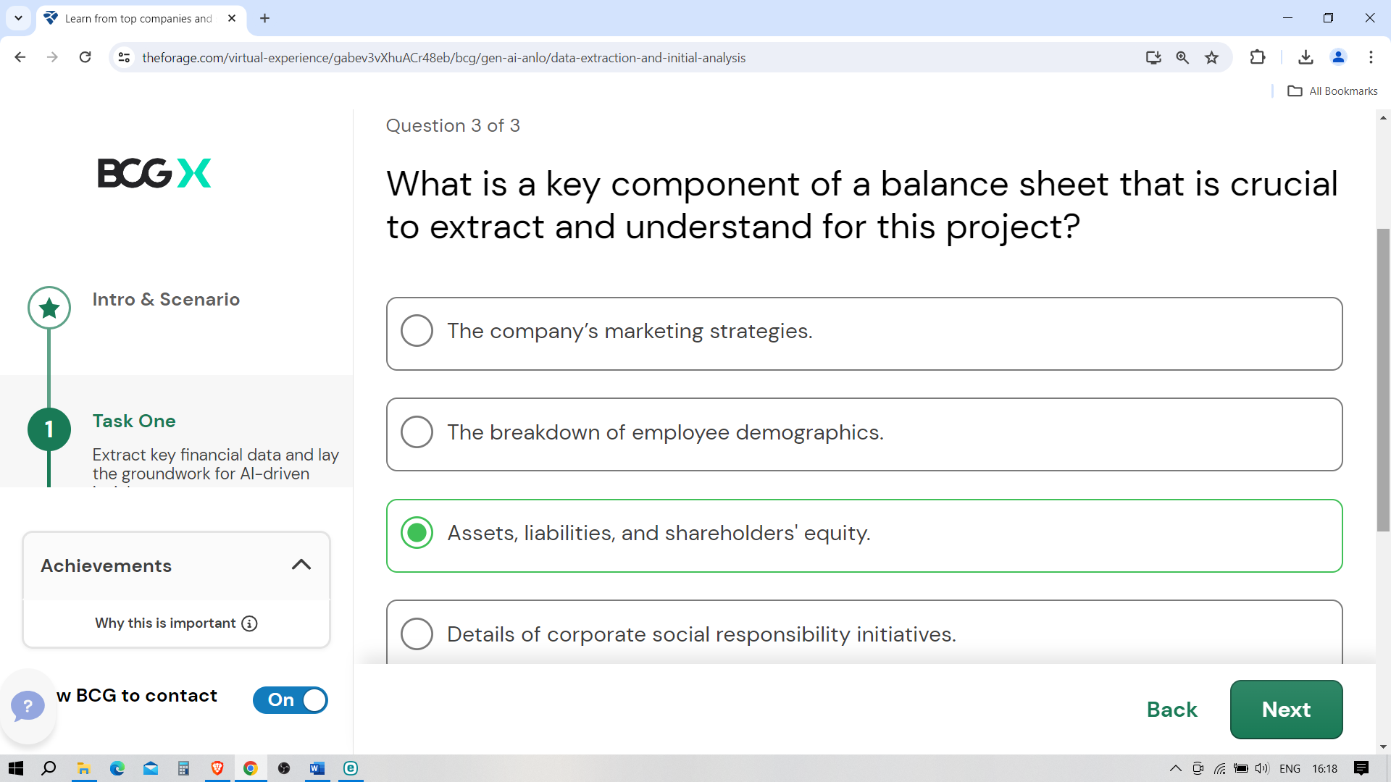

Task instructions

Your task is to manually extract key financial data for the last three fiscal years from the 10-K filings of Microsoft, Tesla, and Apple. Following the data collection, you will use Python to analyze this data, focusing on trends and insights that could inform the development of an AI-powered financial chatbot.

Step 1: Data extraction

**Navigate to the SEC's EDGAR database**:

* [**Microsoft**](https://www.sec.gov/edgar/browse/?CIK=789019&owner=exclude)
* [**Tesla**](https://www.sec.gov/edgar/browse/?CIK=1318605&owner=exclude)
* [**Apple**](https://www.sec.gov/edgar/browse/?CIK=320193&owner=exclude)

**Manual extraction**:

* For each company, find the 10-K filings for the last three fiscal years.
* Extract the following financial figures: Total Revenue, Net Income, Total Assets, Total Liabilities, and Cash Flow from Operating Activities.

**Organize Your Data**:

* Compile the extracted data into an Excel spreadsheet for easy reference during your Python analysis.

Step 2: Preparing your Jupyter Notebook environment

**Install Jupyter** (if not already installed):

* Install Jupyter using pip if you haven't already:

pip install notebook

* Launch Jupyter Notebook:

jupyter notebook

* This command should open Jupyter in your web browser.

**Create a new notebook**:

* In the Jupyter interface, create a new notebook for your analysis.

Step 3: Python analysis in Jupyter

**Import pandas**:

* At the beginning of your notebook, import the pandas library to work with your data.

import pandas as pd

**Load your data**:

* Convert your Excel file to a CSV file for easier handling, then load it into a DataFrame.

df = pd.read\_csv('path\_to\_your\_csv\_file.csv')

**Analyzing trends with pandas**:

* Use pandas to calculate year-over-year changes for each financial metric. You can do this by creating new columns in your DataFrame that represent the percentage change from one year to the next.

df['Revenue Growth (%)'] = df.groupby(['Company'])['Total Revenue'].pct\_change() \* 100

df['Net Income Growth (%)'] = df.groupby(['Company'])['Net Income'].pct\_change() \* 100

* Explore other aggregate functions or groupings to analyze the data across different dimensions (by company, over years, etc.).

**Summarizing findings**:

* Conclude your analysis by summarizing your findings directly in the notebook. Use markdown cells to add narrative explanations of your analysis, discussing the trends and changes in financial metrics you've identified.

Step 4: Documentation and submission

* **Document your analysis**: Use the markdown feature in Jupyter Notebook to document your methodology, observations, and conclusions throughout the notebook.
* **Export your notebook**: Once your analysis is complete, export your Jupyter Notebook as a PDF or HTML file for submission.
  + You can do this from the "File" menu in Jupyter, selecting "Download as" and then choosing your preferred format.

This approach allows you to focus on the core analytical aspects using pandas within a Jupyter Notebook, providing a clear, documented narrative of your financial analysis process. By the end of this task, you'll have a comprehensive understanding of how to analyze financial data programmatically, a valuable skill set for data-driven decision-making.

Example answer

Great work! Take a look at the example answer below to see how a professional would have attempted this task. Think about what you did well and how you can improve.

[[](https://www.theforage.com/virtual-experience/gabev3vXhuACr48eb/bcg/gen-ai-anlo/data-extraction-and-initial-analysis)](https://www.theforage.com/virtual-experience/gabev3vXhuACr48eb/bcg/gen-ai-anlo/data-extraction-and-initial-analysis" \t "_blank)

**[Data Extraction Example Answer](https://www.theforage.com/virtual-experience/gabev3vXhuACr48eb/bcg/gen-ai-anlo/data-extraction-and-initial-analysis" \t "_blank)**

**[Click to download file →](https://www.theforage.com/virtual-experience/gabev3vXhuACr48eb/bcg/gen-ai-anlo/data-extraction-and-initial-analysis" \t "_blank)**

import pandas as pd

# Load the data from the Excel spreadsheet

file\_path = 'path\_to\_your\_excel\_file.xlsx'

df = pd.read\_excel(file\_path)

# Calculate year-over-year growth rates for Total Revenue and Net Income

df['Revenue Growth (%)'] = df.groupby('Company Name')['Total Revenue'].pct\_change() \* 100

df['Net Income Growth (%)'] = df.groupby('Company Name')['Net Income'].pct\_change() \* 100

# Fill NA values that result from pct\_change calculations with 0 or an appropriate value

df.fillna(0, inplace=True)

# Display the dataframe to verify the calculations

print(df)

# Optionally, you could summarize these findings for each company

summary = df.groupby('Company Name').agg({

'Revenue Growth (%)': 'mean',

'Net Income Growth (%)': 'mean'

}).reset\_index()

print("\nYear-over-Year Average Growth Rates (%):")

print(summary)